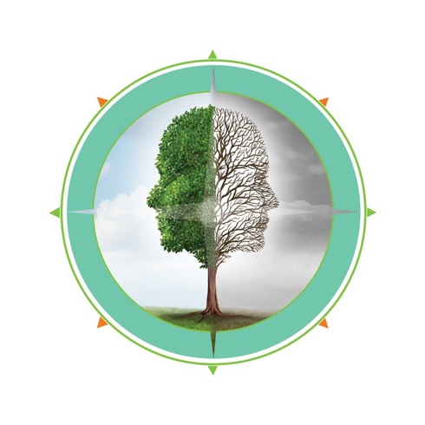

compassion resilience for Schools training of Facilitators

Part 1: November 9th and November 10th 9:00am – 12:00pm EST (virtual)
Part 2: December 7th and December 8th 9:00am – 12:00pm EST (virtual)
Registration https://www.research.net/r/GBKLXDZ

We want to show up strong and compassionate every day
Compassion Fatigue is a normal response when we care about people in distress. Help yourself and your colleagues by learning the skills and supports to facilitate groups that build resilience.

The Compassion Resilience Toolkit for Schools is a flexibly implemented set of evidence-informed resources to build awareness of compassion fatigue and strategies to increase compassion resilience in adults from a system and individual perspective. The resources include activities for large group, small group or team-based use as well as for individual reflection. Included in the 12 sections are activities for leaders and staff on realistic expectations, setting compassionate boundaries, building a workplace culture of compassion, self-care strategies, and links to further learning.

The Training of Facilitators prepares you to bring the toolkit resources to your colleagues. This training is offered as four 3-hour virtual components for a total of 12 hours. Attend as a school team to ideally include: one administrator and 3-4 people who will facilitate with staff. The training includes clarification of leadership roles, rationale for the work, a look at how to inspire culture change through the toolkit, and tips for implementing the toolkit resources matched to the realities of your current organizational commitments and goals.

To learn more about the Compassion Resilience Toolkit for Schools
visit www.CompassionResilienceToolkit.org.

For more information, contact:
Stephanie.bunge@education.ky.gov

This training is being offered through Kentucky Department of Education
and Rogers Behavioral Health

