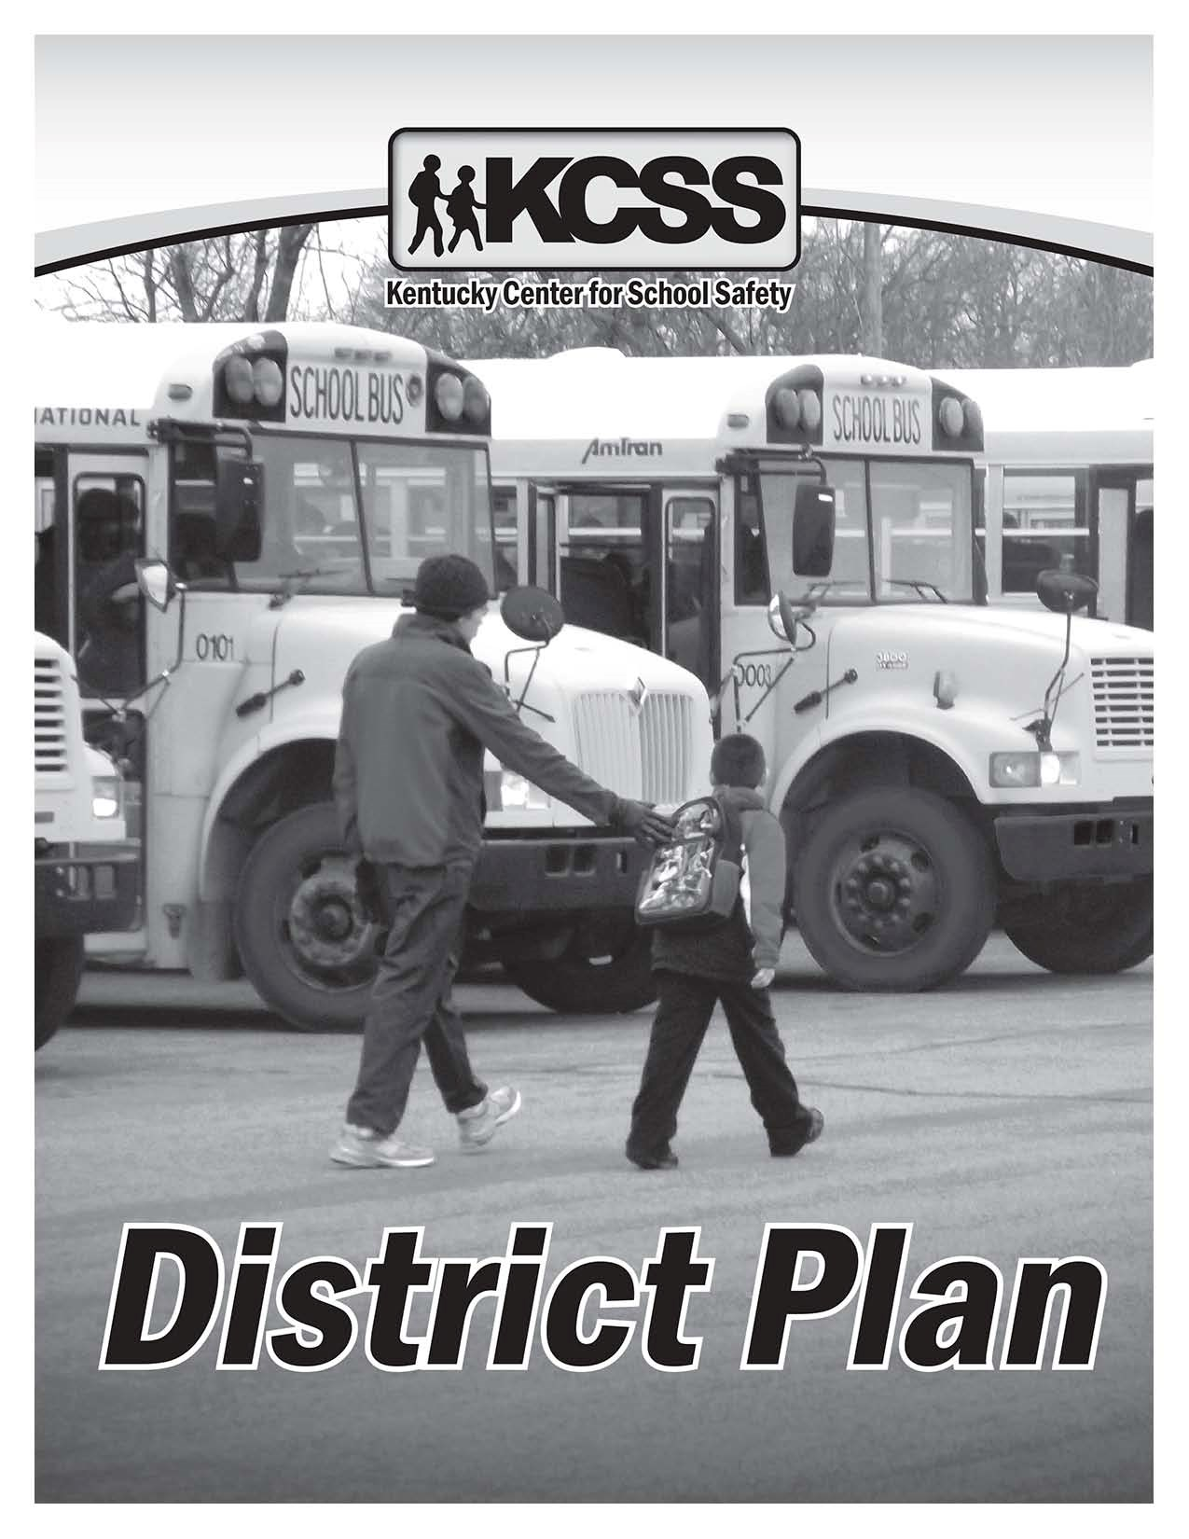
Emergency Management Resource Guide

Checklist for District Planning
Under the direction of the superintendent or designee, each district is to complete the following according to its unique needs and circumstances. Each District Support Team should comprise a variety of school employees, as well as community representatives and stakeholders.
District Plan
- Designate a single “lead contact” for orchestrating district level planning
- Have each team member read or become familiar with this Emergency
Management Resource Guide
- Complete the following:
District Support Team Emergency Numbers
Local / Regional Emergency Response Numbers
Potential Hazards (Part 1)
Potential Hazards (Part 2)
Visitor Screening Policy/Access Control
- Review entire chapter entitled “Creating the Emergency Operations
Plan,” modify for local needs, titles, circumstances
- Review Universal Emergency Procedures, modify for local needs
- Review Emergency Operations Protocols, modify for local needs
- Coordinate district planning with local police, fire, emergency medical, and other emergency responders (review lines of communication between agencies, procedures for interagency collaboration, etc.)
- Prepare a district model Emergency Quick Reference Guide. Each school will adapt the district’s model for individual use
- Establish a timeline and procedures for how the district will support training for administrators and school-based teams (to prepare them to conduct school-based planning)
- Establish a mechanism for individual schools to request assistance in creating school-based plans, and to help mitigate identified hazards
- Designate a district level contact or liaison to monitor individual school’s progress; create a mechanism for schools to submit updated plans on a yearly basis
- Establish a regular meeting or planning schedule for the District Support Team; determine who will attend these meetings (all stakeholders vs.
smaller task force approach)

District Level Plan
The superintendent or designee is ultimately responsible for overseeing ongoing activities in emergency prevention, protection, mitigation, response and recovery. Under his/her direction, the school district should form a district-level team to review the contents of this guide, and to modify it for local use.
Upon completing the revision of this guide, the District Support Team’s role changes to that of support. The District Support Team functions to assist schools in the coordination and allocation of needed resources when the need imposed by the current situation exceeds the affected school’s normal resources.

Forming the District Level Support Team
Suggested Steps for Team Formation
- Superintendent or designee communicates with selected staff in key district roles to recruit them to serve on the district team. As in the local school, a staff inventory should be conducted to determine if any individual has experience or specialized training in any of these areas.
- Superintendent or designee creates list of staff, making sure that all emergency support functions are addressed, including:
District Plan
  - Director of security or law enforcement
  - Director of building and grounds
  - Director of maintenance
  - Director of transportation
  - Director of supply services
  - District level secretary or receptionist
  - Director of community or public relations
  - Director of risk management and safety
  - School psychologists and social workers
  - Personnel with areas of expertise (i.e., CPR, first aid, etc.)
- An initial meeting is held with potential team members to discuss what will be expected for team membership and to outline steps for planning and implementation.
- District-level team identifies possible community agencies and individuals to assist in district planning, such as:
  - Police Department, Fire Department
  - Emergency Medical Services
  - Social Service Agencies (Child Welfare, Juvenile Justice)
  - City/County government
  - Local hospitals, medical and mental health professionals
  - Local/regional emergency management agency
  - Business representatives
  - Clergy, Parents
  - Local American Red Cross
- As much as possible, formalize interagency agreements with Memoranda of Agreements Reference the Appendix A: “Generic School District – Emergency Operations Plan”.
(MOU), letters of support, etc. (samples available at the Kentucky Center for School Safety web site:
www.kysafeschools.org.).
District Plan
- Initially, meet as often as needed to review portions of this guide to modify for local use. Have each team member review specific areas which pertain to their area of expertise (for example, local police and school security review protocols and actions which may involve a security response).
- When the adaptation of this guide is completed, schedule a “kick-off” presentation or training for school administrators to begin the process of school-level planning.
- Ongoing, hold regular team meetings throughout the school year to assist schools in school level planning, to review school specific plans, and to address ongoing issues as they arise (which may include local, state or national issues that may affect the district). Small communities may wish to have all participants in the same meetings; larger districts may need to form smaller task forces to accomplish specific tasks.
- Schedule drills, practice and annual reviews (district and school levels).

District Support Team Emergency Numbers
District Plan
Complete the form below to reflect your district’s offices, adding and deleting as necessary. Include district office phone numbers, with appropriate local terminology for job titles, positions, departments, etc.
Title | Name – Location | Numbers/Cell
Superintendent
Assistant Superintendent
Director of Security/
Law Enforcement
Director of Maintenance
Director of Transportation
Director of Nutritional Services
Director of Supply Services
Director of Safety
Director of Buildings and Grounds
Director of Special Education
Director of Student Support
(counseling, soc. work, etc.)
Director for Safe and
Drug Free Schools
Director of Health or Medical Services
Director of Public Relations
Legal Counsel
Other
Other

Local / Regional Emergency Response Numbers
Complete the form below to reflect your district or regional emergency resources. List local hospitals, emergency services, mental health crisis lines, social service agencies, American Red Cross, regional / local emergency response agencies, etc. It is important in planning stages to form interagency partnerships with law enforcement agencies, fire and rescue, etc. in order to predetermine jurisdiction in the event of ongoing investigations.
District Plan
Agency – Address | Name – Title | Numbers

Potential Hazards (Part 1)
It is vital to record the potential hazards for your geographic area and risks to your district so you know what to expect and what to do to protect students and staff. It is essential to understand that disasters have a cascading effect:
- Forest fires lead to debris flows, mud slides, grassfires and smoke/pollution
- Earthquakes cause fires, loss of water supply, structural damage, chemical leaks and disruption of communications
District Plan
- Flooding blocks roads, damages property, and ruins food supply
- Tornadoes destroy buildings, cause fallen power lines
- A medical epidemic/pandemic creates significant disruptions to the educational and related business routines
In an effort to prioritize these events the District Support Team needs to consider what is most likely to occur in this area and when/if these events have occurred in the past.

Natural  Hazards | Predictability and  Approx. Frequency | Warning  Time | Comments or  Actions to Take
Earthquakes
Severe weather, tornadoes, lightning
Excessive rains, flash floods, flooding
Dam failure
Mud slides
Windstorms
Snowstorms
Sinkholes
Grass or forest fires
Other
Other

Potential Hazards (Part 2)
The District Support Team needs to consider what other human/technological factors, could occur or have occurred in your region:
District Plan
Human or Technological Hazards | Predictability and Approx. Frequency | Warning  Time | Comments or Actions to Take
Bomb threat, or
other terrorism
Arson, fire
Riots
Air pollution,
smog alert
Water or
food pollution
Hazardous
material spills
Nuclear or
radiological accident
Asbestos
Communication systems failures
Water system disruptions
Gas or electric disruption
Transportation systems disruptions
Airplane,
airport hazard
Railroad track,
station hazard
Other

Visitor Screening Policy/Access Control
(In this section create, update or insert your district policy regarding Visitor Screening. Ideally, the individual who is updating this Guide could type, or “cut and paste” the district’s policy here, then delete the text below).
Visitor Screening Suggestions
All visitors shall be addressed with a standardized greeting before being granted
•
access into the building.
Outdoor and exit door signs to direct all visitors to the entrance they should enter.
•
Utilize positive welcoming signs that clearly indicate where you want visitors to
•
go (i.e. Office, Reception Area, etc.)
All exterior doors should be locked only allowing entrance through one
•
designated entrance.
All visitors should pass through an office area that offers verbal and visual contact
•
with staff.
All visitors sign-in, show identification, leave a deposit such as keys or ID and
•
receive a sticker or other badge.
Designate staff to provide verbal face-to-face contact to inquire about the person’s
•
name, area or room to be visited and nature of the visit.
If person is new to the school or unsure of the room location, a staff member may
•
meet him/her or accompany him/her.
Visitors should return to sign out when leaving the school.
•
There should be no exceptions to the policy.
•
Involve and acquaint parents, parent-teacher organizations, etc. with the policy
•
and the need to know who is in the building.
All teachers and staff should know the policy.
•
All staff should be expected to question people without a badge and ask them to
•
check in with the office before proceeding to the intended room.
District Plan
District Plan

